**Introduction:**

Created an Ionic application which gives Movie data based on the search movie and sentiment analysis which will give the mood information.

**Team members:**

1. Bhavya Sri Sirasanagandla

Contribution: 50%

1. Manideep Nadimpelli

Contribution: 50%

**Objective:**

Create an Ionic application using HTML, CSS, Ionic,Angular and Bootstrap.

1.Created Login ,Registration ,Home, Emotion detection, Movie club pages.

2. Used 'uclassify' and 'themoviedb' for emotion detection and movie info APIs.

3.Created Unit test cases using Jasmine,karma.

**Features:**

* User can register using register page. Added form validations and alert messages.
* User can login once he/she enters the valid details.If not error messages were shown.
* User can select the features like Sentiment Analysis or the Movies info.
* Used 'uclassify' API for sentiment Analysis based on user given info.
* Used ‘themoviedb’ API to get the movie details based on the search.

**Implementation:**

1. Created an angular project in WebStorm IDE. By default, “app” component will be created. Also created 3 components home, register, login, emotion detection , movieclub.

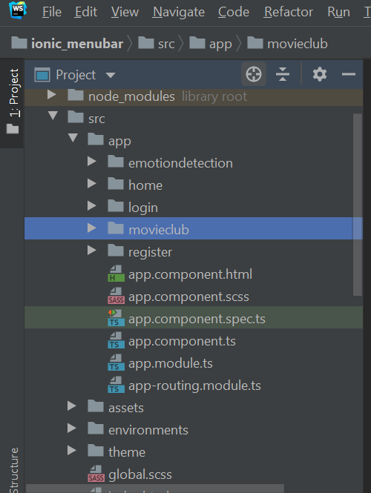

1. Created input tags and added form validations with corresponding messages.

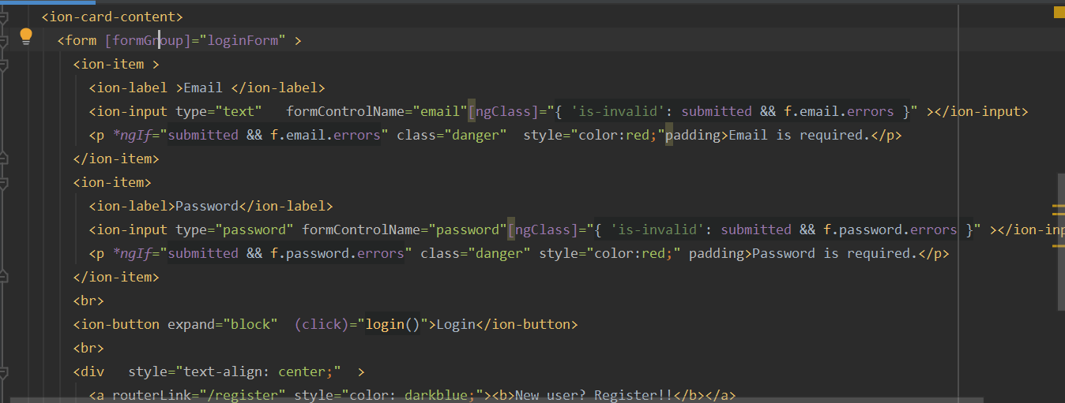

1. Used alert and toaster components in ionic to display the error and success messages.

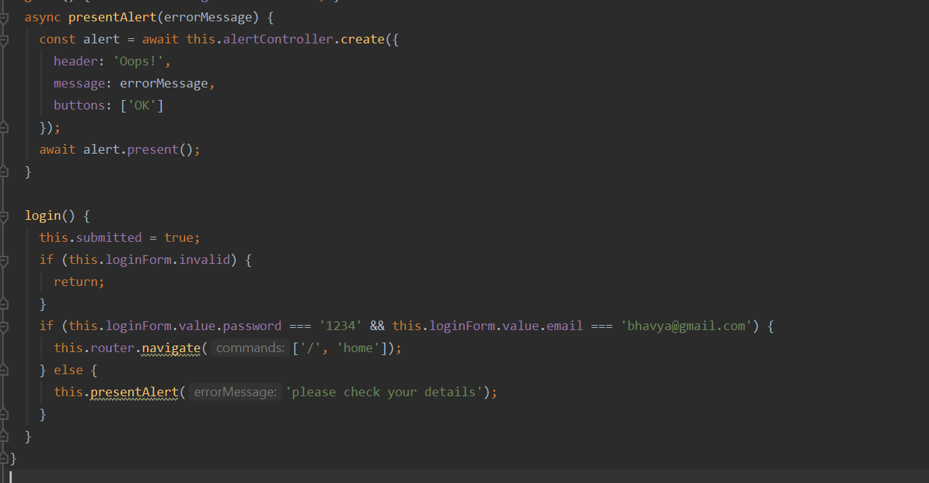

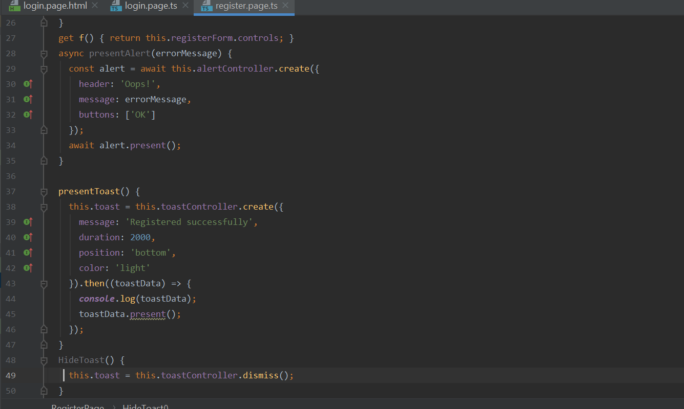

1. Used ‘themoviedb’ API to get the movie details.

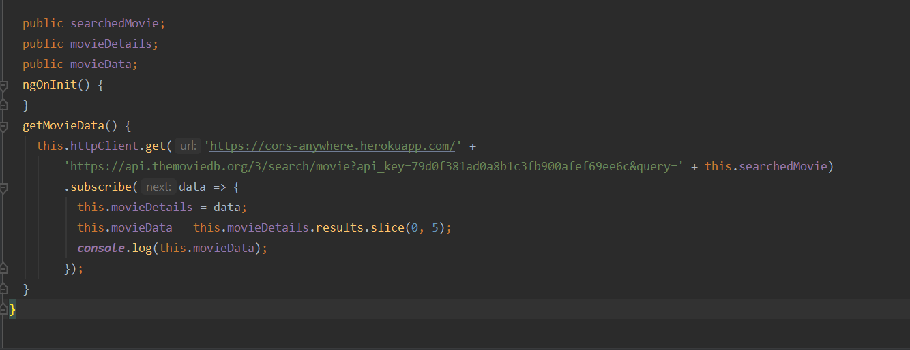

1. Used ‘uclassify’ Api for semantic analysis based on the entered sentence or word.

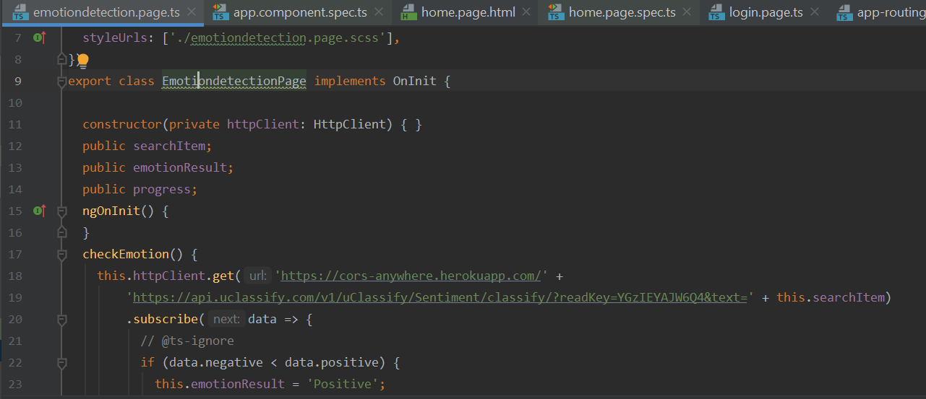

1. Wrote 3 unit test cases using jasmine ,karma.

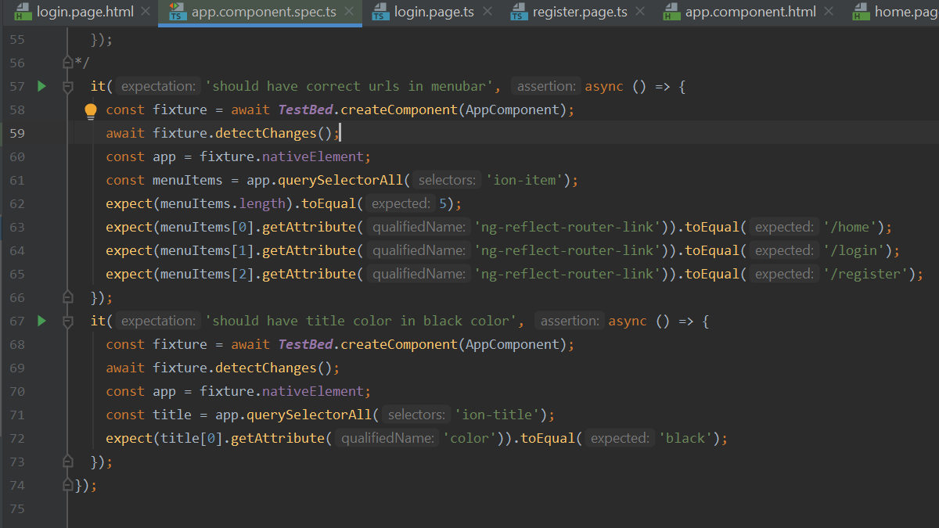

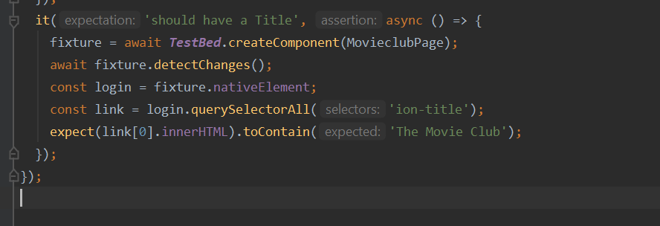

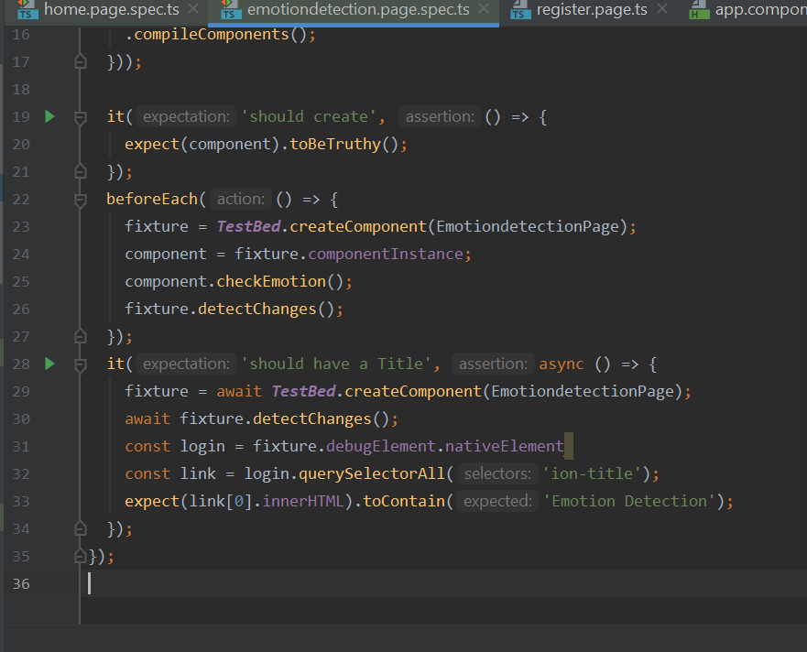

**Design:**

1. Created ionic menu bar using ionic templates.

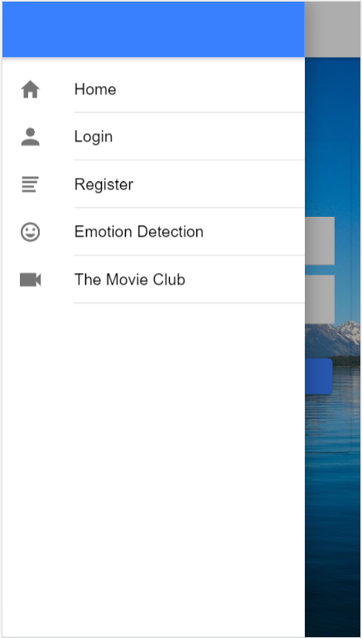

1. By default login page will be shown to the user.

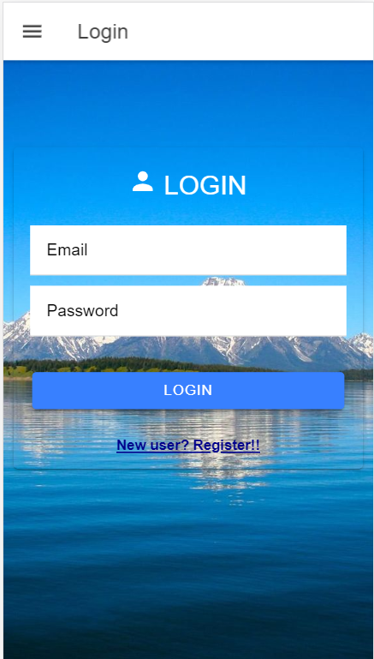

1. If the user doesn’t have any account he can register using register link which will navigate to the registration page.

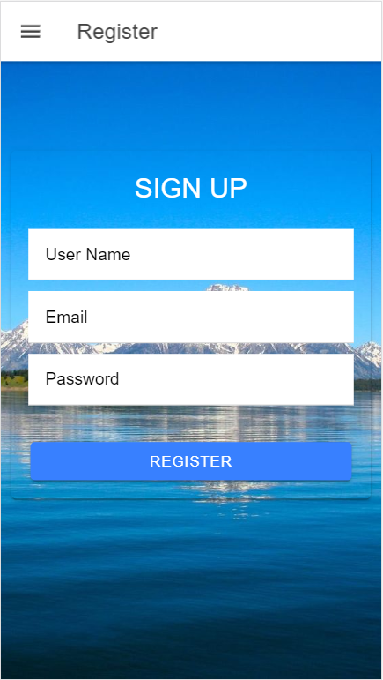

1. Added form validation to display errors.

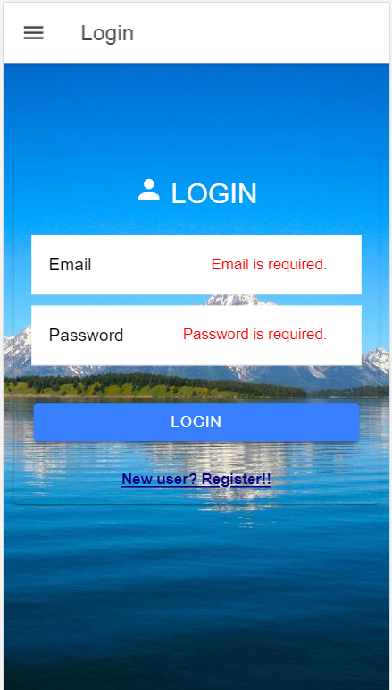

1. If the user enters wrong details added alert message.

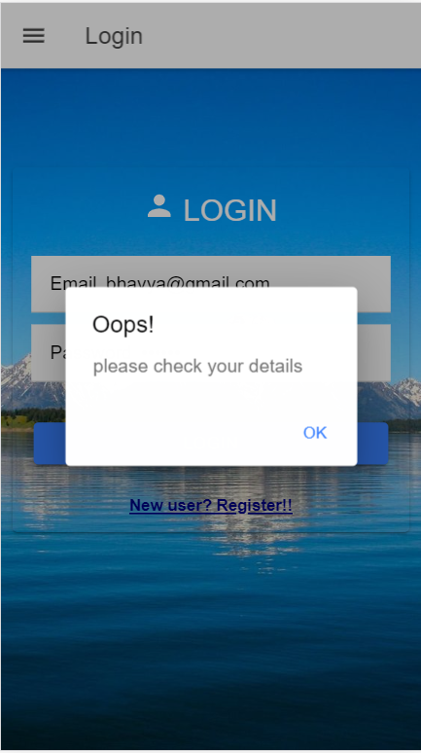

1. Added ionic toaster to display successful registration. After registration user will be redirected to login page.

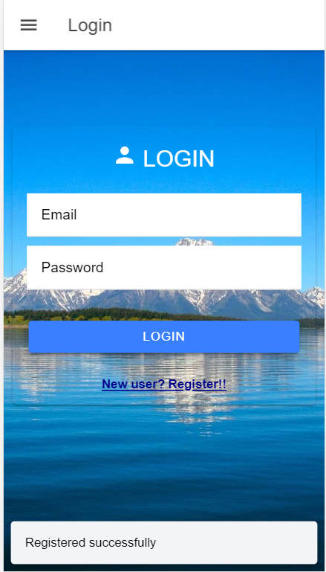

1. Once the user enters the correct details(we have hardcoded) home page will be shown.

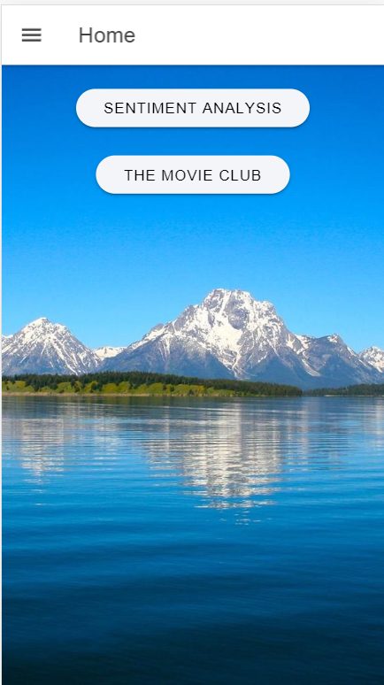

1. Sentiment analysis button will redirect to emotion detection page. Where user can enter a sentence or word and get the details related to that.

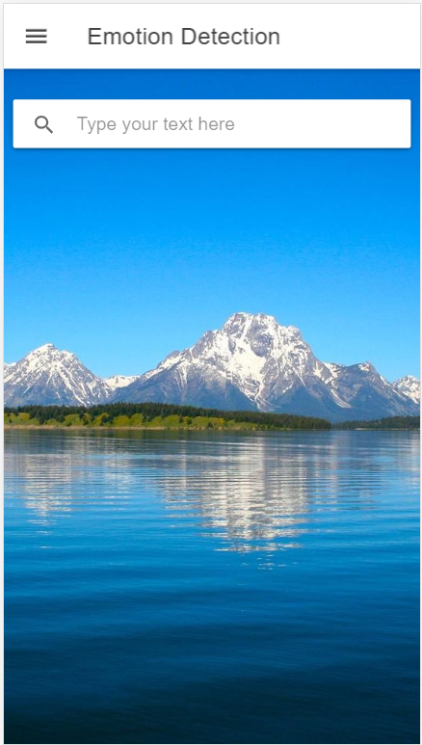

1. Display will be shown based on positive and negative sentences. Used progress bar to show how much positive or negative.

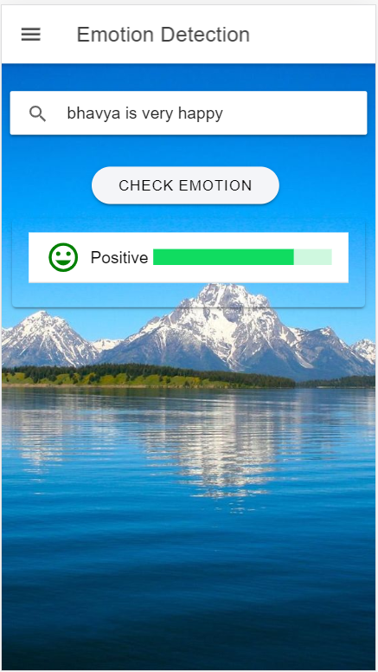

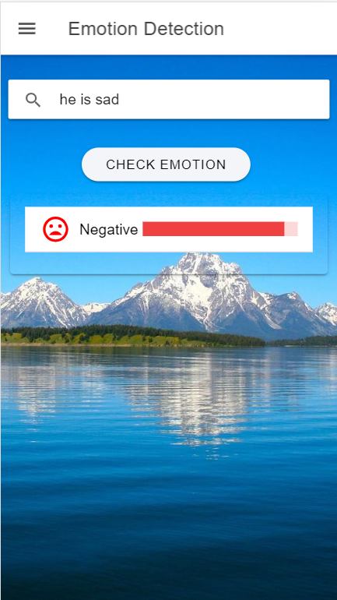

1. When the user clicks on the movie club button in home page ,user will be redirected to movie club page . User can enter any movie name and get the movie details like poster, release date, overview.



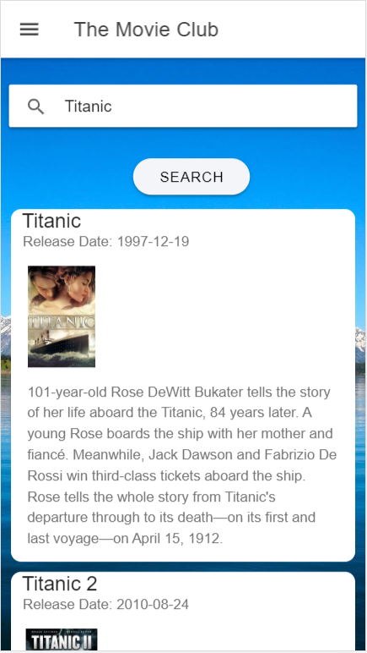

**References:**

* <https://www.w3schools.com/>
* <https://www.themoviedb.org/documentation/api/>
* <https://www.uclassify.com/browse/uclassify/sentiment>
* <https://angular.io/guide/form-validation>
* <https://getbootstrap.com/docs/4.0/getting-started/introduction/>

**Conclusion:**

* We got an idea about Ionic applications and explored various ionic components.